Audit Trail - How To Use It

This is a Manhattan associates Audit Trail. It includes the information provided by a JSON file - information like UserId, Updated By, etc. This information can help find those who is in the system, who updated it, and much more.

This documentation is to show how to use this system.

Table of Contents

Download 2

Zip File 2

Github Desktop 2

Things To Know 3

Column Explainations 5

# Download

### Zip File

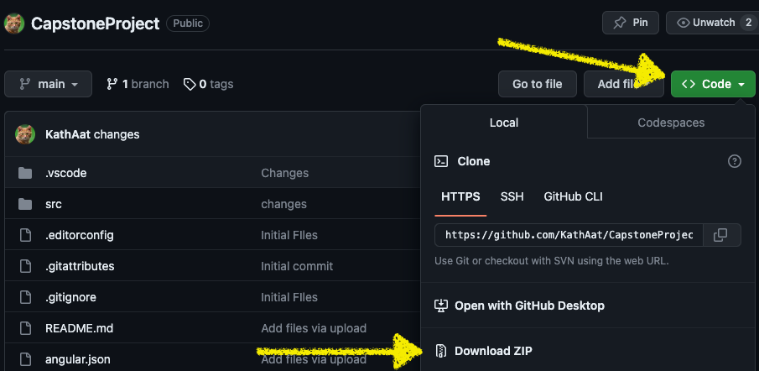

**For the Zip file, once you have it downloaded, open index.html**

### Github Desktop

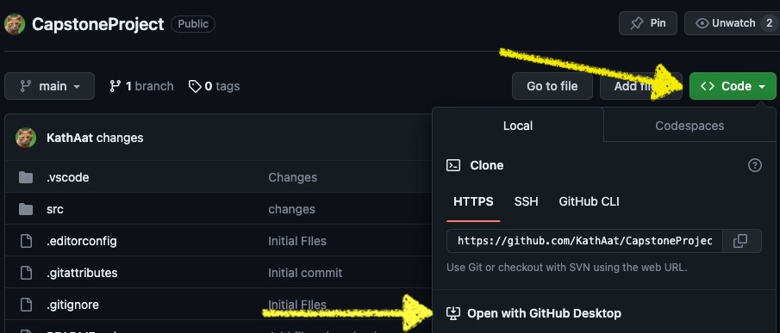

Awesome! Now it has appeared. When you have it open, it’ll look like this:

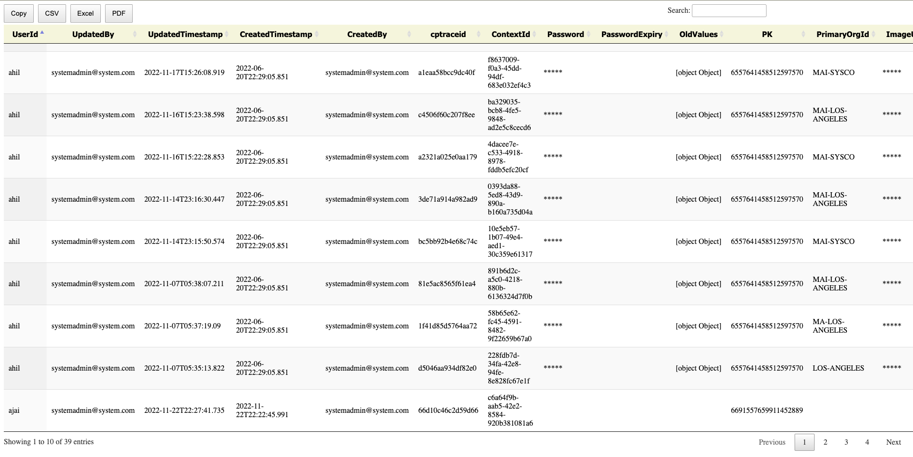

# Things To Know

In order to copy, download it as a pdf, excel file, or csv file, go to the buttons at the top left corner:

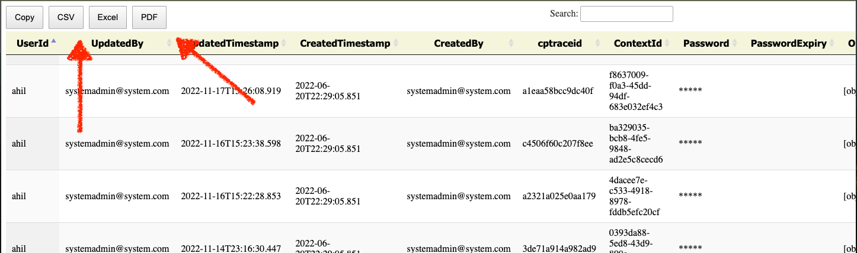

To search go to the search button and it’ll automatically filter:

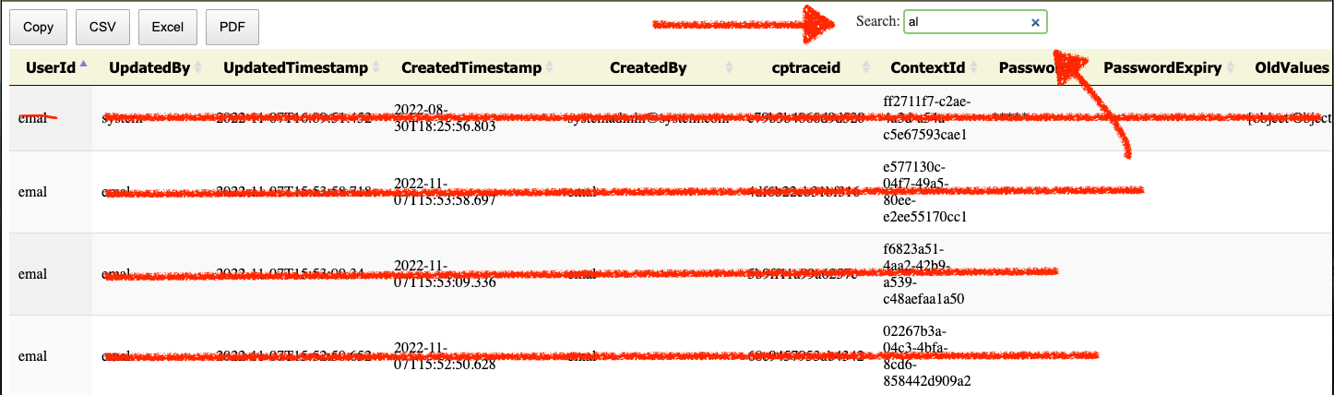

In this example, we searched al and it brought up all UserIds with “al” in it.

To flip through more entries, the buttons to go to the next pages are below. They look like this:



# Column Explainations

Now that we’ve got how to use the UI of it, here’s the column explanations:

* UserId:
  + The user’s ID. Unique and has all of the users information with it. How you identify a user.
* UpdatedBy:
  + Who it was updated by. Will be a UserId or an email.
* UpdatedTimestamp:
  + What time it was updated. Format: YYYY-MM-DD:HH:MM:SS
* CreatedTimestamp:
  + When the UserId was created. Format same as UpdatedTimestamp
* CreatedBy:
  + Who it was created by. Will be a UserId or an email.

All other columns are explanatory.